HARROW COUNCIL

CORPORATE ANTI-FRAUD &
CORRUPTION
STRATEGY 2016 - 2019
CONTENTS Page No

1.0 Foreword by the Leader of Harrow Council Cllr Sachin Shah 3
and Chief Executive Michael Lockwood
2.0 Introduction 5
3.0 Definitions 10
4.0 Aims and Objectives 12
5.0 Fraud Risks 13
6.0 Action Plan 17
7.0 Measures of Success 19
8.0 Reporting and Review 20
9.0 Further reading 21

Appendix 1 – Fraud Response Plan 22
1.0 Foreword by the Leader of Harrow Council, Cllr Sachin Shah and Chief Executive, Michael Lockwood

Fraud and corruption is a very real threat to the UK economy and Harrow Council is not immune to these risks. In May 2016, the Annual Fraud Indicator Report 2016 was published putting estimated fraud and corruption losses affecting the UK at around £193 billion. Losses in the public sector were estimated to be £37.5 billion. These are significant sums of money that are potentially being taken away from the people that need it most, such as the vulnerable, children and the elderly.
Fraud and corruption not only removes resources but can cause untold social harm to individuals and communities. Harrow Council will not tolerate fraud and corruption and will push for the strongest penalties against those that think it acceptable to commit fraud.
Having recently launched our Ambition Plan 2020, it is vital that we are able to protect our limited resources and assets from fraud and corruption so that they are put to best use and support those with the greatest need. This Council is committed to Working together to make a difference for Harrow and in doing so our vision is to:
- Build a Better Harrow

- Be More Business-like and Business Friendly

- Protect the Most Vulnerable and Support Families

Working hand in hand with our vision we have also developed with our employees, values to enable us to achieve the Ambition Plan 2020. These are:-
- Be courageous
- Do It Together
- Make it Happen
We have some tough challenges ahead, in particular the financial pressures that the public sector is facing. The Councils savings target for the 4 year period 2015/16 to 2018/19 is £83m. In balancing the 2015/16 budget, savings of £30.9m were agreed. The target for the three years 2016/17 to 2018/19 was £52.4m. We are showing leadership and ambition even in these difficult circumstances. We are continuing to make Harrow a better place to live and do business.
Our regeneration plans will create thousands of much needed affordable and high-quality homes, bring jobs and investments into the Borough, new schools, cleaner and greener neighbourhoods and an improved entertainment, cultural and leisure offer to bring a new buzz to our high streets.
According to Protecting the English Public Purse 2015 Housing Tenancy Fraud is costing the UK economy in the region of £845 million annually so it is vital that we provide assurance that those families occupying our housing stock are the rightful tenants and we take robust action to remove those tenants unlawfully subletting or not occupying as their principle home. Similarly, once we start building affordable homes, we ensure that those that need our help the most are given priority to occupy.
By 2020 Harrow Council will be moving into a new Civic Centre, designed in consultation with residents to be at the heart of the community and Wealdstone, supporting local businesses, local families and turning round an area that has been ignored for far too long.
At all times it is crucial that we ensure public money is properly spent. This is the basis of the trust which our residents place in the Council. As Harrow’s largest employer, the Council has a duty to make clear to all members, employees and contractors that malpractice in any form will not be tolerated. The authority needs to demonstrate the highest standards of probity and transparency. All council employees are reminded that it is their duty to report any financial or professional misconduct. The Council has a well established 'whistle blowing' procedure and will always investigate when presented with serious concerns.
Whilst all stakeholders have a part to play in reducing the risk of fraud, Elected Members and Senior Management are ideally positioned to influence the ethical tone of the organisation and play a crucial role in fostering a culture of high ethical standards and integrity.
This Corporate Anti-Fraud & Corruption Strategy sets out the responsibilities and behaviours the Council expects from its employees, members and partners. We urge you to study it carefully and join with us in ensuring Harrow Council retains its good name for corporate governance and fairness.

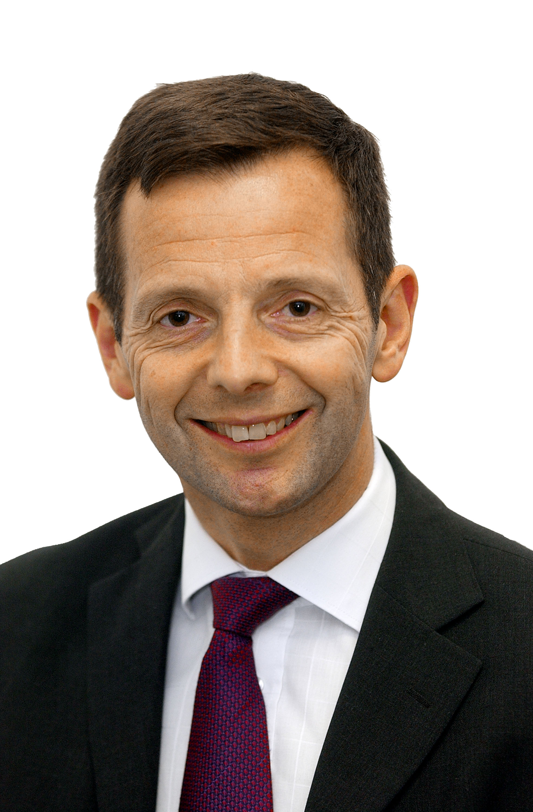
Cllr Sachin Shah Michael Lockwood
Leader of the Council Chief Executive

2.0 INTRODUCTION

This document sets out the Council’s strategy in relation to fraud and corruption. It has the full support of, the Corporate Strategy Board, relevant Members including the Governance, Risk Management and Standards Committee (GARMS), the Leader and Portfolio Holder for Finance & Commercialisation.
The Council takes its responsibilities for the stewardship of public finances very seriously and is committed to the highest standards of transparency and accountability in order to ensure appropriate use of public funds and assets. It has a duty to prevent fraud and corruption, whether it is attempted by someone within or outside of the Council such as another organisation, a resident, an employee, contractor or Councillor. The Council is committed to creating and maintaining an effective anti-fraud and corruption culture, by promoting high ethical standards and encouraging the prevention and detection of fraudulent activities.
In all its dealings, the Authority will adhere to the seven principles of public life set out in the Nolan Committee’s report on Standards in Public Life.

- Selflessness

Holders of public office should take decisions solely in terms of the public interest. They should not do so in order to gain financial or other material benefits for themselves, their families or their friends.

- Integrity
Holders of public office should not place themselves under any financial or other obligation to outside individuals or organisations that might influence them in the performance of their official duties.
- Objectivity

In carrying out public business, including making public appointments, awarding contracts, or recommending individuals for rewards and benefits, holders of public office should make choices on merit.

- Accountability

Holders of public office are accountable for their decisions and actions to the public and must submit themselves to whatever scrutiny is appropriate to their office.

- Openness

Holders of public office should be as open as possible about all the decisions and actions that they take. They should give reasons for their decisions and restrict information only when the wider public interest clearly demands. Openness requires an inclusive approach, an outward focus and a commitment to partnership working.

- Honesty

Holders of public office have a duty to declare any private interests relating to their public duties and to take steps to resolve any conflicts arising in a way that protects the public interest.

- Leadership

Holders of public office should promote and support these principles by leadership and example.

The Council will not tolerate fraud or corruption by its councillors, employees, suppliers, contractors, customers or any other attacks on its resources by criminals and will take all necessary steps to investigate all allegations of fraud or corruption and pursue sanctions available in each case, including removal from office, dismissal, prosecution and robust recovery of losses through both civil and criminal means.
To fulfil the Council’s Ambition Plan 2020, the authority has to ensure that fraud, corruption and misappropriation is minimised. Every pound lost to fraud and corruption is a reduction in resources and negatively impacts the authorities’ ability to deliver its objectives.
Our strategy is based upon three key principles: Acknowledge, Prevent and Pursue, and aligns with the Local Government Counter Fraud & Corruption Strategy 2016-2019

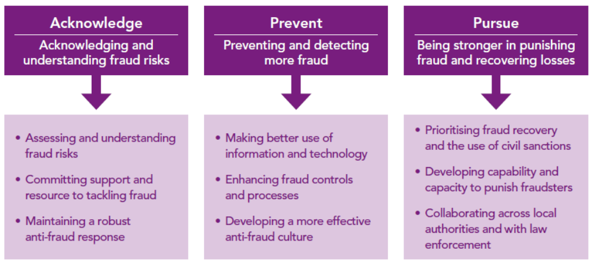

Accompanying the three principles are six overarching themes to assist the organisation ensure that our counter fraud response is comprehensive and effective. These are often referred to as the six Cs.

- Culture – create a culture in which beating fraud and corruption is part of normal business

- Capability – ensuring that the range of counter fraud measures deployed is appropriate to the fraud risks

- Capacity – deploying the right level of resources to deal with the level of fraud risk

- Competence – having the right skills and standards in place

- Communication – raising awareness, deterring fraudsters sharing information and celebrating success

- Collaboration – working together across internal and external boundaries with colleagues and other agencies, sharing resources, information skills and learning

2.1 Scope

This strategy applies to:
- All Harrow Council employees (including volunteers and agency staff);
- Councillors;
- Staff and Committee Members of council funded voluntary organisations;
- Harrow Council’s partners;
- NHS partners;
- Maintained schools;
- Council suppliers, contractors and consultants;
- Customers

2.2 Roles & Responsibilities

RESPONSIBILITIES STAKEHOLDER | SPECIFIC RESPONSIBILITIES
Chief Executive | Ultimately accountable for the effectiveness of the Council’s arrangements for countering fraud and corruption.
Director of Finance (Section 151 Officer) | To ensure the Council has adopted an appropriate anti-fraud strategy, there is an effective internal control environment in place and there is an adequately resourced and effective Internal Audit and Corporate Anti Fraud Service to deliver ‘counter-fraud’ work.
Monitoring Officer and Director of Legal & Governance Services | To advise Councillors and Officers on ethical issues, standards and powers to ensure that the Council operates within the law and statutory Codes of Practice.
Governance, Audit, Risk Management and Standards Committee (GARMSC) | To monitor on a regular basis the Council’s approach to tackling fraud and corruption and promote an anti-fraud culture
Councillors | To comply with the Code of Conduct and related Council policies and procedures, to be aware of the possibility of fraud, corruption and theft, and to report any genuine concerns accordingly.
External Audit | Statutory duty to ensure that the Council has adequate arrangements in place for the prevention and detection of fraud, corruption and theft.
Internal Audit | Internal audit is responsible for evaluating the potential for the occurrence of fraud and how the organisation manages fraud risk
Corporate Anti Fraud Team | Responsible for the co-ordination of the authorities anti fraud and corruption strategy, including the measures in place to acknowledge, prevent and pursue fraud and corruption activity. This also includes the a key co-ordination role in the National Fraud Initiative (NFI) which is a fraud prevention and detection exercise based around bulk data matching that is led by the Cabinet Office every two years.
Corporate Directors, Directors, Heads of Service and Service Managers | Manage the risk of fraud and corruption. To promote staff awareness and ensure that all suspected or reported irregularities are immediately referred to Corporate Anti Fraud or Internal Audit. To ensure that there are mechanisms in place within their service areas to assess the risk of fraud, corruption and theft and to reduce these risks by implementing strong internal controls. It is vital that this group show leadership in supporting investigations into fraud and corruption and that they are responsive to implementing actions arising from this work. Their role in the NFI exercise is to provide data for matching and to analyses the outputs form the matching exercise and take appropriate action
Employees | Our employees are the first line of defence against fraud and corruption. They are expected to conduct themselves in ways which are beyond reproach, above suspicion and fully accountable. Also responsible for reporting malpractice through well established ‘whistleblowing’ procedures. Employees are expected to adhere to the Employee Code of Conduct, Financial Regulations and Contract Procedure Rules

3.0 DEFINITIONS

What is fraud?
The Fraud Act 2006 details the legal definitions of fraud, and is used for the criminal prosecution of fraud offences. The Council also deals with fraud in non-criminal disciplinary matters.
For the purposes of this document fraud defined as; the dishonest action designed to facilitate gain (personally or for another) at the expense of the Council, the residents of the Borough or the wider national community.
The definition covers various offences including; deception, forgery, theft, misappropriation, collusion and misrepresentation. Although use in this context is not intended to limit the full use of the Fraud Act 2006 in the investigation and prosecution, by the Council, of any offences.
What is corruption?

Corruption is the offering or acceptance of inducements designed to influence official action or decision making. These inducements can take many forms including cash, holidays, event tickets, meals.

The Bribery Act 2010 received Royal Assent on 8 April 2010 and reforms the criminal law to provide a new, modern and comprehensive scheme of bribery offences that will enable courts and prosecutors to respond more effectively to bribery at home or abroad.

Bribery Act offences

There are four key offences under the Act:-

• bribing of another person (Section 1)
• accepting a bribe (Section 2)
• bribing a foreign official (Section 6)
• failing to prevent bribery (Section 7)

Section 7 is a corporate offence but an organisation will have a defence to this offence if it can show that it had in place ‘adequate procedures’ designed to prevent bribery by or of persons associated with the organisation.

Further guidance is available from the Ministry of Justice to explain to organisations what action is required to ensure they are compliant.

What is theft?
Theft is stealing any property belonging to the Council or which has been entrusted to it (i.e. client funds), including cash, equipment, vehicles, data.
Theft does not necessarily require fraud to be committed. Theft can also include the stealing of property belonging to our staff or members whilst on Council property.
What is money laundering?

Money laundering is the process by which criminals attempt to 'recycle' the proceeds of their criminal activities in order to conceal its origins and ownership and which leaves them with money that cannot be traced back. All employees are instructed to be aware of the increasing possibility of receiving requests that could be used for money laundering and illicit requests for money through e-mails. Detailed guidance is set out in the Council’s Money Laundering Policy.

Any service that receives money from an external person or body is potentially vulnerable to a money laundering operation. The need for vigilance is vital and if there is any suspicion concerning the appropriateness of the transaction then the Council’s Money Laundering Policy should be followed. Officers should also seek the advice from management, Internal Audit or the Corporate Anti Fraud Team. The Council’s Money Laundering Reporting Officer (MLRO) is the Director of Finance.

4.0 AIMS AND OBJECTIVES

The aims and objectives of the Anti-Fraud and Corruption Strategy are to:-

- To protect the Council’s valuable resources by ensuring they are not lost through fraud and corruption but are used for improving the delivery of services to Harrow residents through the successful implementation of the Harrow Ambition Plan 2020.

- To gain a better understanding of local fraud and corruption risks impacting on the Council’s ability to deliver its objectives.

- Create an ‘anti-fraud’ culture which highlights the Council’s zero tolerance of fraud, corruption and theft, which defines roles and responsibilities and actively engages the public, Councillors and employees, by raising awareness of fraud both internally and externally.

- Actively seeks to increase the Council’s resilience to fraud and corruption through the raising of fraud awareness.

- To provide a best practice counter-fraud service which:

- Proactively deters, prevents and detects fraud, corruption and theft.

- Investigates suspected or detected fraud, corruption and theft.

- Enables the Council to apply appropriate sanctions and recover losses.

- Provides management reports and recommendations to inform policy, systems and control improvements, thereby reducing the Council’s exposure to fraudulent activity.

- Create an environment that enables the reporting of any genuine suspicions of fraudulent activity. However, we will not tolerate malicious or vexatious allegations or those motivated by personal gain and, if proven, we may take disciplinary or legal action; and

- Work with our partners and other investigative bodies in collaboration to strengthen and continuously improve our arrangements to prevent fraud and corruption.

5.0 FRAUD RISKS

The Council seeks to fulfil its responsibility to reduce fraud and protect its resources by a strategic approach consistent with that outlined in both CIPFA’s Code of Practice on Managing the Risk of Fraud and Corruption and in the Local Government Fraud Strategy – Fighting Fraud Locally, and its three key themes of Acknowledge, Prevent & Pursue. Fraud risks are corporate risks faced by all of our services and, as with other risks, are the responsibility of the Directorates to manage and mitigate. The Corporate Anti Fraud Team and Internal Audit, however, provide advice, knowledge and support to the Directorates in the managements of these risks.

ACKNOWLEDGE | Committing Support | The Council’s commitment to tackling fraud threats is clear. We have whistleblowing procedures and support those who come forward to report suspected fraud. All reports will be treated seriously and acted upon. Staff awareness of fraud risks will be gained through e-learning, face to face development sessions, Internal Audit and CAFT reports and general consultation and advice provided.
ACKNOWLEDGE | Assessing Risks | We will continuously assess those areas most vulnerable to the risk of fraud as part of our risk management arrangements and annually meet with the Directorate Management Teams to discuss fraud, corruption and internal control risks and seek to assess in terms of likelihood and impact. These risk assessments along with known fraud risks identified by investigation work and national reports and fraud patterns will inform our annual programme of works for both Internal Audit and Corporate Anti Fraud.
ACKNOWLEDGE | Robust Response | We will strengthen measures to prevent fraud. Internal Audit and Corporate Anti Fraud will work with management and our internal partners such as Human Resources, Finance and Legal to ensure new and existing systems and policy initiatives are adequately fraud proofed.

PREVENT | Better use of Information Technology | We will explore the use of data and analytical software to prevent and detect fraudulent activity. We will always look for opportunities to share data and fraud intelligence to increase our capability to uncover potential and actual fraud as we have done in becoming members of the London Housing Fraud Hub. We will continue to play an active part in National Fraud Initiative (NFI) data matching exercise. Whilst the Corporate Anti-Fraud Team plays a co-ordination and support role in this exercise, it is management that is responsible for processing the actual matches. The Corporate Anti Fraud Team will ensure there is a robust follow up process to ensure that high risk matches are pursued where appropriate.
PREVENT | Enhancing fraud controls and processes | We will educate managers with regard to their responsibilities for operating effective internal controls within their service areas. We will promote strong management and good governance that provides scrutiny and independent challenge to risks and management controls. Internal Audit reviews will seek to highlight vulnerabilities in the control environment and make recommendations for improvement. The Corporate Anti-Fraud Team investigations and reports will also provide management with actions to improve controls to reduce fraud risks.
PREVENT | Anti-fraud culture | We will promote and develop a strong counter fraud culture, raise awareness, provide a fraud e-learning tool and provide information and guidance on all aspects of our counter fraud work.

PURSUE | Fraud Recovery | A crucial element of our response to tackling fraud is recovering any monies lost through fraud. This is an important part of our strategy and will be rigorously pursued, where possible.
PURSUE | Punishing Fraudsters | We will apply realistic and effective sanctions for individuals or organisations where an investigation reveals fraudulent activity. This may include legal action, criminal and/or disciplinary action. We will also seek to publicise successes to act as a deterrent to those seeking to commit fraud.
PURSUE | Enforcement | We will investigate instances of suspected fraud detected through the planned proactive work; cases of suspected fraud referred from internal or external stakeholders, or received via the whistleblowing procedure and prioritised on a fraud risk basis. We will work with internal / external partners/organisations, including law enforcement agencies where common ground exists or where intelligence can be lawfully shared.

5.1 Current Fraud Landscape

The fraud landscape is ever changing and requires constant review. The Corporate Anti Fraud Team keeps abreast of these changes in a number of ways.

- Membership of the National Anti-Fraud Network (NAFN) which provides the authority with a legal gateway to a wide range of information providers, best practice, legislation updates and sharing of fraud intelligence/bulletins of local and national interest potentially affecting the organisation.

- Membership of the London Borough of Fraud Investigators Group (LBFIG) which meets bi-annually to discuss current fraud work and associated risks, trends and emerging fraud risks developing across London.

- Membership of The Chartered Institute of Public Finance and Accountancy (CIPFA) and the related Counter Fraud Centre and contributor to the Counter Fraud and Corruption Tracker (CFaCT) survey.

- Attendance at relevant counter fraud conferences.

- Contributing and reviewing of National Fraud Reports such as Protecting the Public Purse (PPP) and the Annual Fraud Indicator Report.

- Contributors to the National Fraud Initiative (NFI) exercise led by the Cabinet Office and co-ordinators of the output reports analysis from the exercise.

- Constant review of incoming fraud referrals informing patterns and/or concerns affecting the fraud risk in specific areas.

- Fraud investigation and Internal Audit outcome reports to management highlighting fraud risk control weaknesses with recommendations to strengthen.

- Liaison with the Directorates and their Department Management Teams on an annual basis to discuss fraud risks and periodically when required.

5.2 Current Fraud Risks

The following areas of Council business have been assessed as being high risk to fraud after an assessment drawing on the above sources of information. These considerations form the basis of a proactive annual programme of fraud work in 2016-17 and beyond but are subject to change as the fraud landscape changes.

- Tenancy including the Right to Buy (RTB)
- Housing Needs / Provision
- Council Tax Support / Exemptions / Discounts
- Personal Budgets / Social Care
- No Recourse to Public Funds (NRPF)
- Disabled parking badges
- Cyber security/crime
The development of a fraud risk register will enable a better understanding of local fraud and corruption risks impacting on the Council’s ability to deliver its objectives. Once established, this risk register along with the other sources of fraud risk intelligence referred to in 5.1, will be used to inform the counter fraud approach of the organisation.

5.3 Managing the risk of Fraud & Corruption
Whilst all stakeholders have a part to play in reducing the risk of fraud, Elected Members and Senior Management are ideally positioned to influence the ethical tone of the organisation and play a crucial role in fostering a culture of high ethical standards and integrity.

As with any risk faced by the Council, it is the responsibility of managers to ensure that fraud risk is adequately considered within their individual service areas and in support of achieving strategic priorities, business plans, project and programme objectives and outcomes. In making this assessment it is important to consider the risk of fraud occurring (i.e. proactive) rather than the actual incidence of fraud that has occurred in the past (reactive).

Once the fraud risk has been evaluated, appropriate action will be taken by management to mitigate those risks on an ongoing basis, for example through introducing and operating effective systems of internal control (first line of defence).
Adequate supervision, recruitment and selection, scrutiny and healthy scepticism will not be seen as distrust but simply as good management practice shaping attitudes and creating an environment opposed to fraudulent activity.

Good corporate governance procedures are a strong safeguard against fraud and corruption. The Council’s Governance, Audit, Risk Management & Standards Committee plays a key role in scrutinising the Council’s approach to fraud, its system of controls & risk management; and its wider resiliency to financial irregularity in general (second line of defence).

The Council’s Corporate Anti Fraud Team undertakes a risk based programme of works targeting areas of high risk to fraud and corruption. This is based on consultation with the Directorates, known local fraud outcomes from investigation work, evidence from national reports such as Protecting the English Public Purse 2015 and outcomes from data-matching such as the National Fraud Initiative. This programme of works is approved by the Governance, Audit, Risk Management and Standards Committee.

Internal Audit also undertakes a risk-based assurance programme of work each year developed with input from management and agreed by the Governance, Audit, Risk Management and Standards Committee. This assurance work involves an independent review of systems and procedures, including a review of the management of risk (of both fraud and other types of risk) whereby system weaknesses are brought to the attention of management along with recommendations to strengthen controls within procedures (third line of defence).

6.0 ACTION PLAN

This Strategy sets out the developments and actions the Council proposes to take over the medium term future to further improve its resilience to fraud and corruption. These developments include the following actions:-
ACTION | IMPLEMENTATION DATE | LINKS TO AIMS AND OBJECTIVES
Identify and assess Harrow’s fraud risk exposure affecting the principle activities in order to fully understand changing patterns in fraud and corruption threats and the potential harmful consequences to the authority and our customers | Complete in June annually | 4a, 4b, 4c, 4d
Development of a fraud risk register to be integrated into the existing risk management framework, where significant fraud and corruption risks will be owned and maintained by the directorates | June 2017 | 4a, 4b, 4c, 4d
To be an active participant in the bi-ennial National Fraud Initiative (NFI) exercise and to robustly investigate suspected cases of fraud identified through NFI. The Corporate Anti-Fraud Team are responsible for the co-ordination of the exercise including ensuring that the data sets comply with specification and are securely uploaded to the Cabinet Office. Management are responsible for the review of matches that are returned and for referring suspicions of fraud and corruption to the Corporate Anti Fraud Team | October 2016 & October 2018 onwards | 4c, 4d, 4e, 4g
Raise awareness of fraud and corruption both within the authority and in the community through running awareness campaigns and the publication of fraud successes in local and national media, including the use of all forms of social media | Ongoing throughout the duration of the strategy | 4a, 4c, 4d
Actively seeks to increase the Council’s resilience to fraud and corruption through fraud awareness by ensuring that all existing employees in all directorates undertake a fraud & corruption e-learning course | By March 2019 | 4a, 4c, 4e
Actively seeks to increase the Council’s resilience to fraud and corruption through fraud awareness by ensuring that all new employees in all directorates undertake a fraud & corruption e-learning course | June 2017 | 4a, 4c, 4e
By launching and publicising our strategy raise awareness of fraud and corruption with Senior Managers and Elected Members through a combination of e-training, newsletters and face to face fraud awareness development sessions where appropriate. | April 2017 | 4c, 4e
To refresh the fraud awareness pages on the Hub/Website | September 2017 | 4c, 4d, 4e
To refresh and promote the Council’s suite of anti-fraud related policies and procedures and to ensure that they continue to be relevant to national guidance, e.g. CIPFA Code of Practice on Managing the Risk of Fraud and Corruption | December 2017 | 4a, 4b
To actively maintain the authorities’ membership of the National Anti-Fraud Network (NAFN), the London Borough of Fraud Investigators Group (LBFIG), The Chartered Institute of Public Finance and Accountancy (CIPFA), the London Fraud Hub and all other enforcement partners including the Police, The Border Force and HMRC. Also to be open to new and innovative anti-fraud projects | Ongoing throughout the duration of the strategy | 4e, 4f, 4g
To produce fraud investigation outcome reports for management which highlight the action taken to investigate the fraud risks, the outcome of the investigations e.g. sanction and recommendations to minimise future risk of fraud | Ongoing throughout the duration of the strategy | 4c, 4d, 4f
To explore with Human Resources the possibly of including management responsibility for managing fraud and corruption risks within all managerial role profiles | September 2017 | 4a, 4c, 4d

7.0 MEASURES OF SUCCESS

The successful implementation of this strategy will be measured by the following:-
- Successful implementation of the actions contained within the strategy.
- Increased awareness of fraud and corruption risks by members, managers and employees.
- Evidence that fraud risks are being actively managed across the authority.
- Increased fraud risk resilience across the authority to protect the Council’s assets and resources.
- An anti fraud culture where employees feel able to identify and report concerns relating to potential fraud and corruption.

8.0 REPORTING AND REVIEW

The Council’s approach to suspected fraud can be demonstrated in its Fraud Response Plan / Flowchart - see Appendix 1 - Fraud Response Plan

The Council recognises that the primary responsibility for the prevention and detection of fraud rests with management. If anyone believes that someone is committing a fraud or suspects corrupt practices, these concerns should be raised in the first instance directly with line management then the Corporate Anti Fraud Team or Internal Audit.

Where managers are made aware of suspected fraud by employees, they have responsibilities for passing on those concerns to the Corporate Anti Fraud Team, Internal Audit, and Monitoring Officer in the event of a whistleblowing allegation or the Director of Finance (Section 151 Officer). Managers should react urgently to suspicion of potential internal fraud or corruption.

Head teachers of LA-maintained schools should also notify their Chair of Governors. Notifications must be treated with the utmost confidentiality. Any person that is implicated in the alleged offence should not be included in the notification procedure.

The Corporate Director of Resources, Head of Internal Audit, Corporate Anti Fraud Manager and Director of Finance (s.151 Officer) has responsibility for ensuring the authority has a robust anti fraud and corruption response.

The Council’s Governance, Audit, Risk Management and Standards Committee will ensure the continuous review and amendment of this Strategy and the Action Plan contained within it, to ensure that it remains compliant with good practice national public sector standards, primarily CIPFA’s Code of Practice on Managing the Risk of Fraud and Corruption and the Local Government Fraud Strategy – Fighting Fraud Locally, and meets the needs of Harrow Council.

9.0 FURTHER READING
Further information on related relevant council polices and documentation that was referenced in the development of this strategy can be found below.
- The Council Constitution (Financial Regulations, Contract Procedure Rules, Members and Employees Code of Conduct)
- Recruitment & Selection Policy

- Disciplinary Procedure
- Whistleblowing Policy
- Protocol on Gifts and Hospitality
- Prosecution & Sanction Policy
- Anti-Money Laundering Policy
- The Regulation of Investigatory Powers Act 2000 (RIPA) Policy

- Information Security Policy
- Risk Management Strategy & Policy
- Corporate Anti Fraud Team web pages www.harrow.gov.uk/fraud
- Annual Fraud Indicator Report 2013
- Annual Fraud Indicator Report 2016
- Fighting Fraud and Corruption Locally 2016, The Local Government Counter Fraud and Corruption Strategy
- CIPFA Counter Fraud Centre
- CIPFA Code of Practice Managing the Risk of Fraud and Corruption 2014
- Protecting the Public Purse 2015
- Protecting the London Purse 2015
- National Fraud Initiative Report 2016
- UK Anti-Corruption Plan 2014
- UK Government Serious and Organised Crime Strategy
- Local Government Association Guide - Tackling Serious and Organised Crime

Appendix 1 – Harrow Council Fraud Response Plan / Flowchart

Fraud allegation received
Report to CAFT/IA & log case on fraud system
Sufficient evidence to investigate?
Investigation Plan
Internal fraud
External Fraud
Investigation outcome report
Fraud proven?
Management report
Follow up recommendations
Yes
No

Risk assessment of fraud allegation & gather intelligence

No
Yes

Log decision and feedback where appropriate

Serious & organised fraud?
Meet with management/HR?
Investigation
Investigation

Consider suspension?
Police investigation / arrest
Management investigation

Instigate disciplinary process
Disciplinary hearing

Disciplinary appeal

Sanction / Prosecution
Management report
CPS Prosecution on Police arrest cases
Recover losses
Follow up recommendations
Seek to publicise

Final Budget Report 2017/18
Public Sector Internal Audit Standards

